**Home Equity Reverse Mortgage Information Technology**

**(HERMIT)**

**HERMIT System Changes – Release 5.8**

**Release Date: 06/15/19**

**Document Date: 06/11/19**

June 2019

**INTRODUCTION**

The Home Equity Reverse Mortgage Information Technology (HERMIT) software release version 5.8 consists of the following system changes:

Table of Contents

Servicer Related Changes 2

1. Closing and Funding Date Federal Holiday Rule 2

2. New Security Role: Master Servicer Role (MSR) Owners 2

3. New Field MOE NBS 6

4. Track Deferral End Date via timeline 6

5. CT 22 Assignment Requests - Check for Eligible NBS when below 97.5% of Max Claim Amount (MCA) 7

6. Negative Claim to include Zero AOP Total Claim Amount 8

7. Claims – Section 311 MIP on Parent CT23 and Supplemental CT24 after CT23 8

8. Claims Detail Report - Add Claim Paid Date to search criteria 8

9. Delegation of Claims to HUD Claims Processors 9

NSC / Assigned disposition Related Changes 10

10. Assigned Disposition Loss Mitigation – Pre-Foreclosure timeline 10

11. New Asset Sale Timeline 11

12. Updated Assigned Case sub-status hierarchy 12

13. New Notes Search Capability 12

14. New Set-Aside Transaction & Assigned Compliance Timeline - Hardest Hit Funds 13

If you have any questions regarding the functionality of the software release, please contact the HERMIT Help Desk at 561-899-2610 or at [servicingsupport@hermitsp.com](mailto:support@hecmsp.com). If you have any policy related questions, please send an email to HUD at [answers@hud.gov](mailto:answers@hud.gov).

# Servicer Related Changes

## Closing and Funding Date Federal Holiday Rule

The HERMIT system was updated to allow users to enter Closing Date and Funded Date on Sundays and on all Federal holidays when setting up loans using the Loan Setup page.

The HERMIT system was updated to allow users to enter Closing Date and Funded Date on Sundays and on all Federal holidays when setting up loans using the B2G functionality.

**List of Federal Holidays is below which you can now enter for Closing and Funded Dates:**

* New Year's Day
* Memorial Day
* Independence Day
* Labor Day
* Thanksgiving Day
* Christmas Day
* Birthday of Martin Luther King, Jr.
* Presidents/Washington's Birthday
* Columbus Day
* Veterans Day

## New Security Role: Master Servicer Role (MSR) Owners

**Access to HERMIT Application**

A new Application role was added for the “Master Servicer”. The new role must access only loans, which may span across multiple sub-servicers, in which they are the Master Servicer; in other words, meaning they own the Mortgage Servicing Rights to the HECM loan.

**Add new field named “Master Servicer” to Loan search page**

The new role will have read only access to the HERMIT application. Users will have access to Loan module and Endorsed module, which includes timeline search, from the top menu. The new field is available on certain search windows to enable a Master Servicer to monitor their loans.



A new field called Master Servicer was added to Loan Search area on Loan page. Master Servicer field is Read only for “Master Servicer – Read Only” users on the Loan Search page.

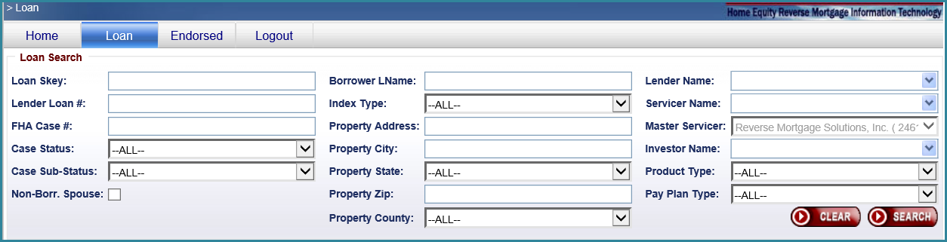

Master Servicer field is blank for all other users on Loan Search page and user cannot select Master Servicer to search.

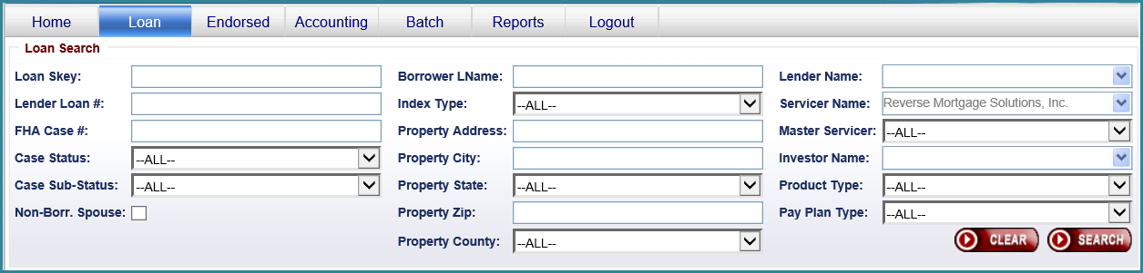

The Master Servicer role can only search and be granted access to loans in which they are the Master Servicer for.

Master Servicer users will have read only access to following tabs:

* Loan Balance
* Loan Details
* Transactions
* Contacts
* Property
* Documents
* Notes
* Audit Tracking
* Alerts
* Repayment Plan
* Change of Plan
* Servicer Info

Master Servicer Description column has been added to the Loan Search Results section. Master Servicer Description column is sortable. Master Servicer Description column is now part of Export to Excel file.

Master Servicer field has been added to Endorsed Timeline Search pages

A new field called Master Servicer was added to Timeline Search area on All Endorsed Timeline search pages. Master Servicer field is Read only for “Master Servicer – Read Only” users on all Endorsed Timeline search pages.

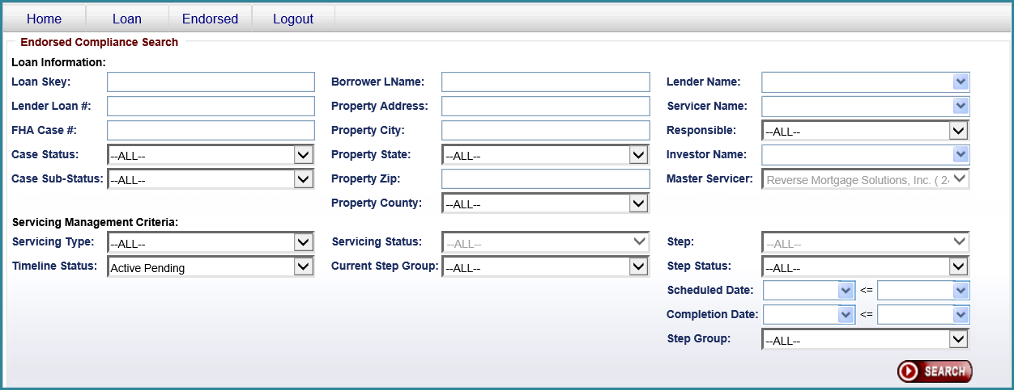

Master Servicer field is blank for all other users on all Endorsed Timeline Search pages and user cannot select Master Servicer to search.

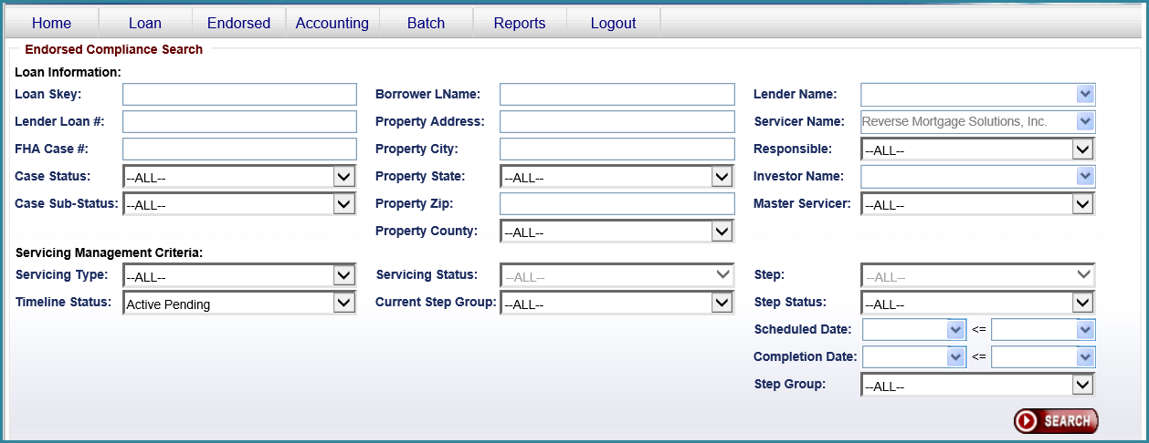

Master Servicer column has been added to the Search Results section. Master Servicer column will be sortable. Master Servicer column will be part of Export to Excel file.

**Loan Setup and B2G Loan Setup**  
Loan Setup process was updated to set Master Servicer equals Current Servicer. B2G Loan Setup process was updated to set Master Servicer equal to Current Servicer.

**A New section called “Master Servicer” was added on the Servicer Info page**

New section called Master Servicer on Servicer Info page was added. This section displays Master Servicer information.

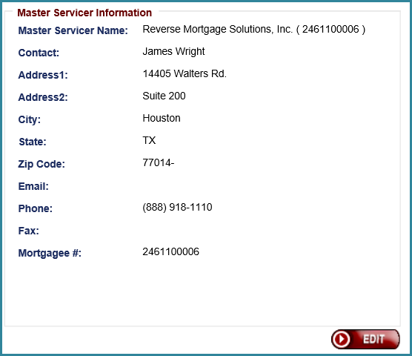

Servicer Manager users will have access to change Master Servicer on loan by clicking the EDIT button. System will add Audit tracking when Master Servicer is updated on any loan in the system.

**New B2G upload file**

New B2G upload file was created to update Master Servicers in bulk. Servicer Managers will have access to B2G file and will be able to upload in the system. Servicer Managers will be able to upload the file by going to Batch/Servicer File Upload page.

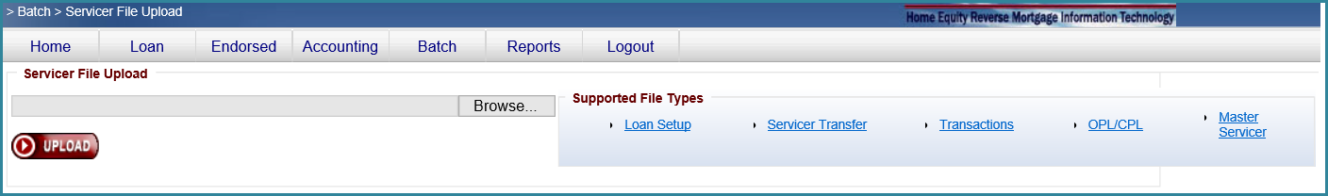

B2G file will have two fields. FHA Case # and To Master Servicer mortgage number.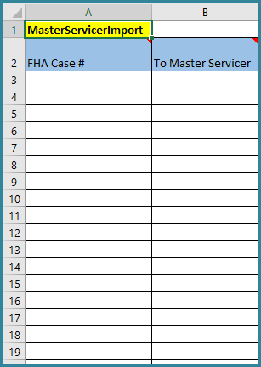

Following validations are added to upload this file.

* FHA case # must be valid
* Servicer mortgage number must be valid
* FHA case # must belong to Servicer that is attempting to update Master Servicer.

Upon uploading the file, Master Servicer will be updated on the loans immediately. Audit tracking has been added.

**Monthly Lender Reconciliation**

The new Master Servicer mortgagee number has been added to the Lender Reconciliation file.

## New Field MOE NBS

To differentiate between Non-Borrowing Spouse (NBS) and MOE (Mortgagee Optional Election) NBS, a new checkbox for MOE is displayed in the Loan Header area under “Borrower Information” section. The Contacts page also has a new check box called “Mort Opt Election (MOE)” located between the existing “Deactivate NBS” and “Eligible NBS” boxes. The new checkbox is not editable by users.

The MOE box is checked when the Contact Type is Non-Borrowing Spouse and the FHA Case # Assign Date on the Loan Details screen is NULL or BEFORE August 4, 2014 (Refer to Mortgagee Letter 2015-15).

## Track Deferral End Date via timeline

**Add new triggered step to Due & Payable w/o HUD Approval Timeline – Endorsed loan**

System creates a Due & Payable w/o HUD Approval Timeline automatically when deferred status on a loan is changed from “Yes” to “No” (No more eligible NBS’s on the loan). When the Due & Payable w/o HUD Approval Timeline is created automatically, a new triggered step has been added to the Due & Payable w/o HUD Approval Timeline.

New step: NBS deferral period has ended. Schedule Date will be Current Date. New step will auto complete with Current Date.

If the Due & Payable w/o HUD Approval Timeline is created due to all borrowers being deceased and no NBS’s were on the loan, then this new step “NBS Deferral Period has Ended” will not be added into the Due & Payable w/o HUD Approval timeline.

**Add new triggered step to Due & Payable timeline – Assigned loan**

System creates a Due & Payable Timeline automatically when deferred status on a loan is changed from “Yes” to “No” (No more eligible NBS’s on the loan). When the Due & Payable Timeline is created automatically, a new triggered step has been added to the Due & Payable Timeline.

New step: NBS Deferral Period has Ended. Schedule Date will be Current Date. New step will auto complete with Current Date.

If the Due & Payable Timeline is created due to all borrowers being deceased and no NBS’s were on the loan, then this new step “NBS Deferral Period has Ended” will not be added into the Due & Payable Timeline.

## CT 22 Assignment Requests - Check for Eligible NBS when below 97.5% of Max Claim Amount (MCA)

**Check for Eligible NBS when 97.5% of MCA**

A new validation occurs when servicer creates the Claim Type - 22 Assignment Timeline and checks the box “Assign prior to MCA reaching 97.5%” on a loan with no eligible NBS contact record. HERMIT will display the following error message:

“*There is currently no active eligible NBS (Non-Borrowing Spouse) on this loan. Please add the eligible NBS through the HERMIT Contacts* *page*.”

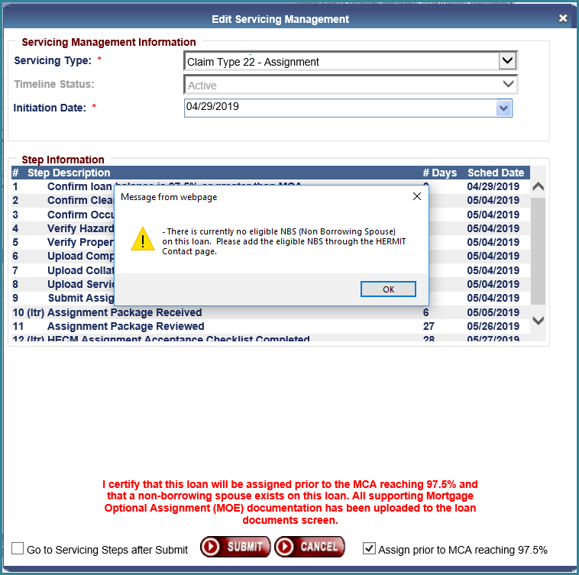

## Negative Claim to include Zero AOP Total Claim Amount

The HERMIT Negative Claim process will apply to claims with Zero AOP totals as well as totals that are negative. The Total Claim Paid amount must be greater than zero in order to file the claim / submit to HUD for claim approval. If the Total Claim Paid amount is equal to zero (or the claim amount is a negative amount), the Negative Claim validation will be displayed when “Finalize and Submit Claim” is clicked. The Negative Claim worksheet displaying the zero amount can be saved to Documents by clicking the “Print HECM Worksheet” link.

* **TIP**: clicking “View HECM Worksheet” allows the user to view but does not auto-image the document. To save a copy to Documents, click on “Print HECM Worksheet”.

**Data**: Following the Release, claims that were previously approved by HUD with zero Total Claim Paid amount will have the CT24 timeline updated to Inactive, the “No Pay Order” set on the loan, and a note added that reads “The CT24 timeline was changed to Inactive and No Pay Order was set due to Zero AOP / Claim total”.

## Claims – Section 311 MIP on Parent CT23 and Supplemental CT24 after CT23

Updates were made to the MIP pulled into Section 311 of the claim form:

1. **MIP in Section 311 on Parent CT23** was updated to include prorated MIP through Approved for Payment date. For a period of time this MIP was not included on the CT23 Parent claim but was included on the Supplemental CT24 after a CT23.
   1. **For Parent CT23 approved prior to this change where the MIP was not included in Section 311 of the Parent Claim and the Supplemental CT24 has not been approved yet, HERMIT will automatically calculate the remaining unpaid MIP into Section 311 of the Supplemental CT24 claim at the time of HUD’s CT24 Approval.**
2. **MIP in Section 311 on Supplemental CT24 after CT23** was updated to ensure MIP does not overlap with MIP included in the UPB / Block #17 amount and is pulled in properly from the Loan > Transactions page.

Use the HERMIT Over Claim process to remit any funds due to HUD

* **TIP:** For a reminder how the UBP / Block #17 is calculated, refer to the latest Claims Mapping Document on the HERMIT Resources page [Claims Mapping (includes CT 24)](https://www.hud.gov/sites/dfiles/Housing/images/HERMIT%20Claims%20Mapping%20Document.docx)

## Claims Detail Report - Add Claim Paid Date to search criteria

New report search criteria “Claim Paid Date” from and to date range was added to the search screen for the “Claims Detail” report under Reports > Servicer Reports > Daily Reports. The date range is optional and can be used in combination with other report search criteria.

The file type has been updated to .csv, previously the file was generated as .xls.

## Delegation of Claims to HUD Claims Processors

This change in HERMIT will automatically delegate initial incoming claims to HUD Claims Processors for review at the time the claims are filed by the servicer.  This feature will allow the HUD Claims-Mgr I user role to modify the list of Claims Processors and delegation order as needed. There will also be a function to inactivate individual Claim Processors and capability to inactivate the entire automatic delegation process as needed.  The automatic claims delegation feature will be located on a new page under the Admin screen in HERMIT. It will allow initial incoming claims to be auto delegated according to the criteria set in HERMIT.  This will facilitate a more balanced allocation of work among the HUD Claims Processors and will be faster and more efficient than the former process that required an authorized HUD user to access the Servicing Mgmt. screen and manually assign these claims to HUD Claims Processors one claim at a time.  The existing ability to manually assign claims to Claims Processors will remain active and unchanged. The HUD Claim Processor (Responsibly Party) assigned to a claim can be verified using the Servicing Mgmt tab.  Claims that are pended back to servicers will bypass this auto-delegation feature when they are resubmitted to HUD.  HERMIT will continue to automatically return these resubmitted claims to the HUD Claims Processor initially assigned to that claim.

# NSC / Assigned disposition Related Changes

## Assigned Disposition Loss Mitigation – Pre-Foreclosure timeline

**Add Foreclosure Attorney dropdown to the Assigned/Disposition/Loss Mitigation -Pre-Foreclosure timeline**

Foreclosure Attorney dropdown has been added to the Assigned/Disposition/Loss Mitigation - Pre-Foreclosure Timeline and appears when the optional step “HUD Approval/Attorney Assignment” is being added to the timeline. Foreclosure Attorney dropdown is a required field.

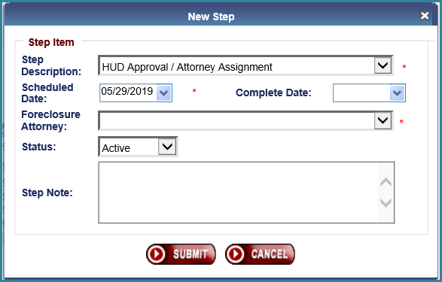

After adding Foreclosure Attorney using optional step “HUD Approval / Attorney Assignment”, Foreclosure Attorney will be displayed in the Assigned/Disposition/Loss Mitigation - Pre-Foreclosure Servicing Mgmt Tab and will be editable via the Edit button and can be changed at any time. This timeline can be inactivated (existing functionality), if needed, to start a new Assigned/Disposition/Loss Mitigation - Pre-Foreclosure timeline.

Once the Foreclosure Attorney is set in the Assigned/Disposition/Loss Mitigation - Pre-Foreclosure timeline it will flow over to the Assigned/Foreclosure timeline as read only in the Servicing Management tab as this attorney is needed to populate in some of the letters.

When adding new Assigned/Foreclosure Timeline, Foreclosure Attorney dropdown will display Foreclosure Attorney selected in Assigned/Disposition/Loss Mitigation - Pre-Foreclosure timeline. This field will be read only and cannot be updated.

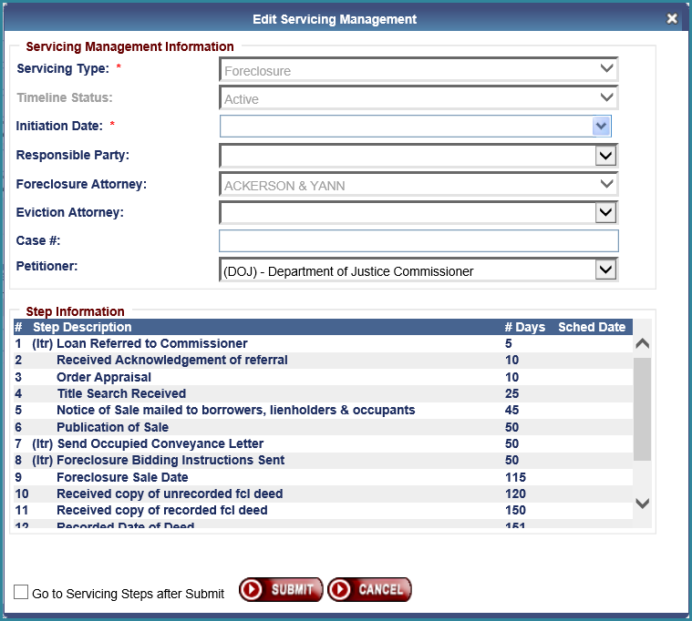

Foreclosure Attorney dropdown on the Servicing Mgmt Tab of the Assigned/Foreclosure Timeline will be read only field and value of the Foreclosure Attorney field will come from the Assigned/Disposition/Loss Mitigation - Pre-Foreclosure Timeline. If this Foreclosure Attorney needs to change, it needs to be updated in Assigned/Disposition/Loss Mitigation - Pre-Foreclosure Timeline.

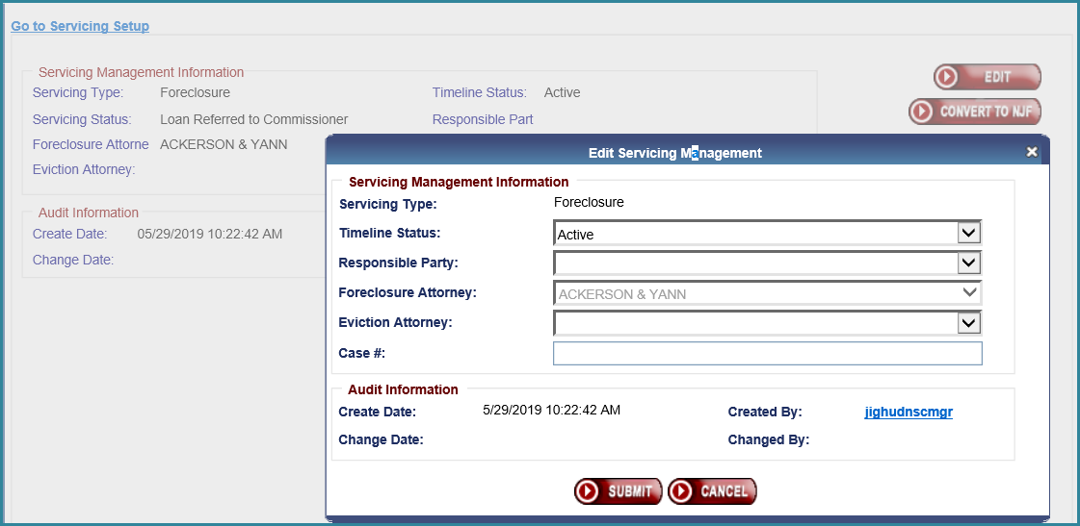

## New Asset Sale Timeline

A new timeline named “Asset Sale” was added to the Assigned/Disposition area. User Roles HUD NSC Staff and HUD NSC Manager can create and edit the new timeline. An active Assigned Due & Payable timeline is required to create an Assigned Disposition - Asset Sale Timeline. If there is no active Due & Payable Timeline, the following error message is displayed: “Asset Sale Timeline cannot be created unless there is an active Due & Payable Timeline present on the loan”.

When the loan is Terminated with a Terminate – Asset Sale transaction, the step “Asset Sale Complete Date” shall be completed with the Transaction Date of the termination. This step will be completed if the Termination is added manually by a user, or via script.

## Updated Assigned Case sub-status hierarchy

The case sub-status hierarchy for Assigned Disposition loans has been updated. Case Sub Status “Repurchase” is now below “Loan Active” and “Asset Sale” was moved below “Repurchase.” For a loan that is not Loan Active, the top priority hierarchy is “Repurchase” and 2nd highest is “Asset Sale”. This only applies to loans with an Assigned Disposition.

The new order of the top three Sub-Statuses is:

1. Loan Active
2. Repurchase
3. Asset Sale

## New Notes Search Capability

A new menu option called “Note Search” has been added on the top menu in HERMIT application. All HUD and HUD Contractor roles below has been able to access the new Notes Search page.

* + Cash
  + Cash Supervisor
  + Customer Service
  + Default
  + Documentation
  + First Mortgage
  + Release
  + Release Supervisor
  + Supervisor/Management
  + Preservation and Protection Specialist
  + HUD Claims-B/R
  + HUD Claims-Mgr I
  + HUD Claims-Mgr II
  + HUD Claims-Staff
  + HUD Financial Mgr
  + HUD NSC-Mgr
  + HUD NSC-Staff
  + HUD Read Only
  + HUD SF Premium Mgr
  + HUD SF-Staff

Note Search Filter has been added to this page. Following Search fields are added.

* + - Note Type – Dropdown menu (copy of Note Type dropdown from “Notes” tab)
    - Note Text – Free Text search
    - Loan Skey
    - FHA Case #
    - Case Status – Dropdown menu (defaults to Assigned)
    - Case Sub-Status – Dropdown menu
    - Product Type – Dropdown menu
    - Created Date: Date Range (Create Date to – Create Date from) (Create Date of the note)
    - Lender Name – HUD will be able to search for any Lender
    - Servicer Name - HUD will be able to search for any Servicer
    - Investor Name - HUD will be able to search for any Investor

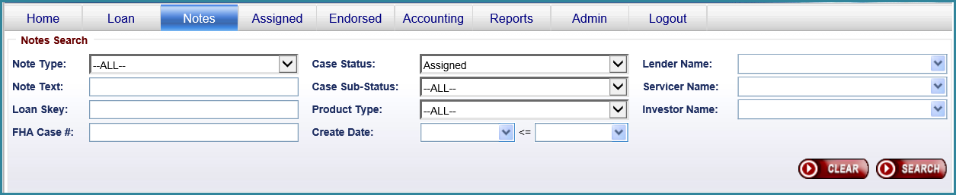

Users will be able to view and update actual notes by clicking on a Note record. User will be able to click on “Go to Notes Search” link in Notes Result area to go back to Notes search page.

User will be able to Export Notes to CSV. “Export to Excel” link will be displayed above Notes Result. The Export Notes uses the standard HERMIT export limit of 150,000. If the record set is larger than 150,000 the user can filter using the Create Date Range (Create Date to – Create Date from).

## New Set-Aside Transaction & Assigned Compliance Timeline - Hardest Hit Funds

**New timeline Hardest Hit Administration**

This applies to only Assigned loans. When entering the Hardest Hit Funds Set Aside Setup transaction the Hardest Hit Fund timeline will automatically be created (like Loss Draft). However, if you try to manually create a Hardest Hit Fund timeline from the timeline setup area in HERMIT without a Hardest Hit Set Aside being present then the following error will display.

**Error:**

* There are no Hardest Hit funds available for this loan.
* You can only setup an Insurance/Hardest Hits Funds Administration timeline for loans that have available Hardest Hit funds.
* Please select another servicing Type.

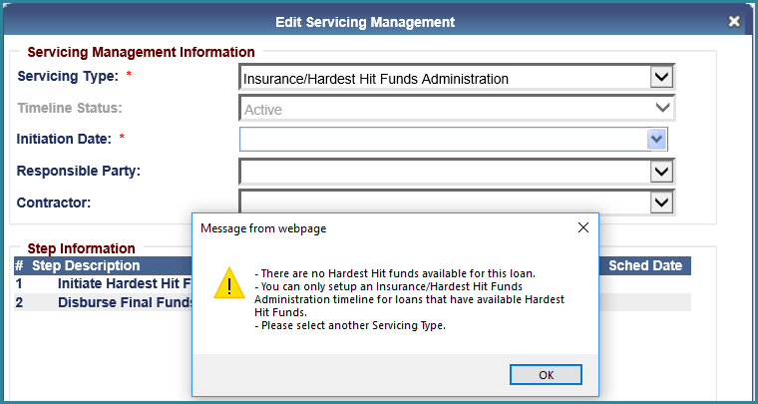

New timeline has been added to Assigned/Compliance area. The new timeline is called “Insurance/Hardest Hit Funds Administration”. Following fields will be added when timeline is being created.

* Servicing type: Required field
* Timeline Status: Defaults to “Active” – Read only field
* Initiation Date: Required field – Date entered must be <= Current Date
* Responsible Party – Optional field
* Contractor – Dropdown menu

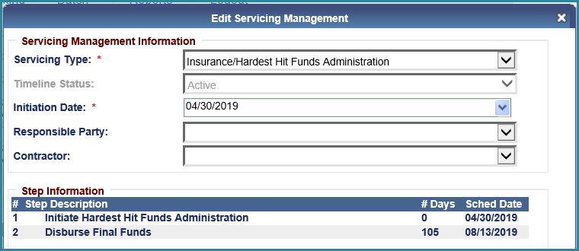

Multiple active timelines allowed at a time.

Following steps have been added to this new timeline. See attached spreadsheet with Hardest Hit Funds Timeline steps.



Following roles can create and manage Hardest Hit Funds Administration timeline.

* CLS Cash
* CLS Cash Supervisor
* CLS First Mortgage
* CLS Supervisor/Management
* HUD NSC Manager

You should be able to edit the Responsible Party field from the Hardest Hit Administration Timeline Servicing Mgmt tab and be able to inactivate the timeline.

This new Hardest Hit Funds timeline will keep track of the remaining balance from the Hardest Hit set aside on the Servicing Management page.

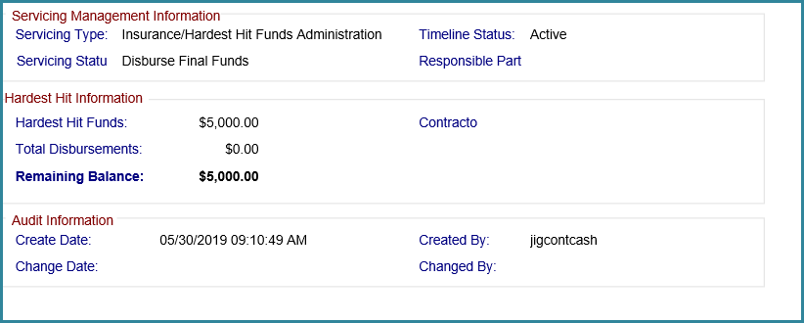

**New Hardest Hit Funds set aside – Setup transaction - All loans serviced by HUD**

Following roles can create Hardest Hit Funds Administration Set Aside transaction

* CLS Cash
* CLS Cash Supervisor

New “Hardest Hit Funds – Setup” transaction will be available in the Transaction -> Set Aside screen for all loans serviced by HUD when the user clicks the “NEW” button.

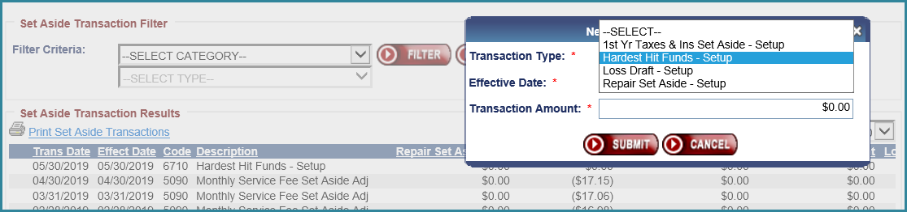

New column called Hardest Hit Amt is added to Set Aside Transaction Results area between LESA Amt and Total Trans Amt columns.

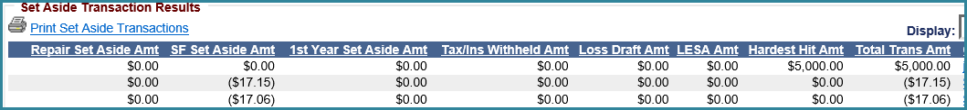

Hardest Hit Funds – Setup transaction will not affect the Loan balance.

Multiple Hardest Hit Funds – Setup transaction cannot be created on the same FHA Case Number.

Hardest Hit Funds – Setup transaction will have an adjustment Transaction Code. Adjustment transaction will be Hardest Hit Funds - Setup Adj. Below are the 2 HERMIT SM transaction codes for the Hardest Hit Fund Setup.

|  |  |
| --- | --- |
| **Transaction Code** | **Transaction Code Description** |
| 6710 | Hardest Hit - Setup |
| 6740 | Hardest Hit  - Setup Adj |

**New Hardest Hit – Disbursement/Transaction - All loans serviced by HUD**

A new transaction Category is created to allow users to enter Hardest Hit Transactions. The new Transaction Category is named “Hardest Hit Funds”.

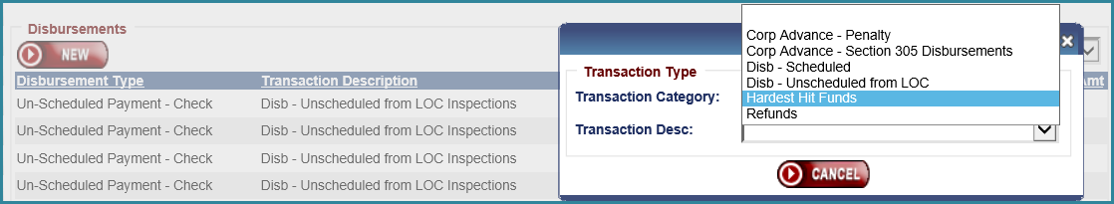

Two new transactions codes are added for Hardest Hit Transaction Category along with their adjustment codes. Transaction Desc will display following transaction options.

* Hardest Hit Final – Disb .
* Hardest Hit Not Final – Disb .

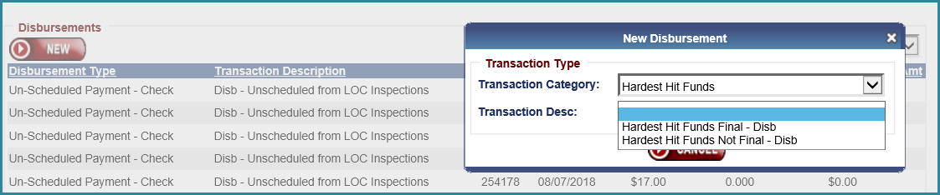

Below are the 4 HERMIT SM transaction & adjustment codes for the HH Fund disbursements

|  |  |
| --- | --- |
| **Transaction Code** | **Transaction Code Description** |
| 6750 | Hardest Hit Not Final - Disb |
| 6751 | Hardest Hit Final - Disb |
| 6790 | Hardest Hit Not Final - Disb Adj |
| 6791 | Hardest Hit Final - Disb Adj |

There is a new disbursement type in the Accounting Disbursement page called “Hardest Hit Funds – Check”

The same roles that can print the checks from the Accounting Disbursement page can print these checks. Once they are printed the Final or Not final transactions will be logged against the Hardest Hit Funds set aside and the remaining Hardest Hit Funds will be reflected (and show in the Hardest Hit Funds timeline’s servicing mgmt. page)

Appropriate transaction will be added to Transactions/Set Aside page after check is printed.

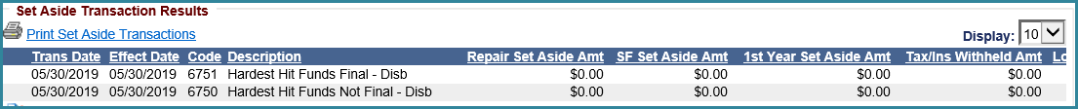

Adjustment transaction will be added to Transactions/Set Aside page after check is voided.



User will not be able to add a disbursement greater than remaining Hardest Hit Funds. If user attempts to add more than available an error is received. Error: The current disbursement amount of [Entered Amount] will create a negative Hardest Hit Set Aside

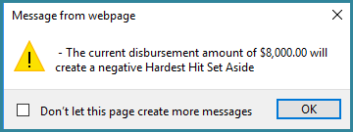

This remaining “Hardest Hit Funds Amount” will also show on the Loan Balance page under the current Loss Draft amount field.

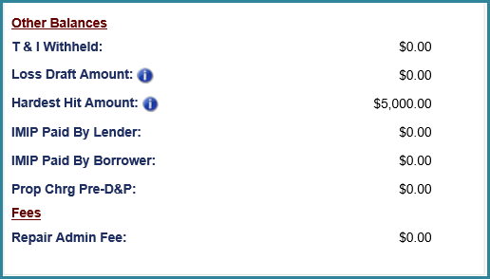

Hardest Hit Funds Final and Not Final transactions will not affect the Loan balance.

**Accounting Module**

All these new Hardest Hit Funds Setup, Setup adj transactions and Final and Not final transaction and Final and Not Final adj transactions will flow over to the Accounting module. This set aside will function like the current Loss Draft set aside that is programmed today.

**Reports**

The Hardest Hit transactions are now included in Transaction Activity report.